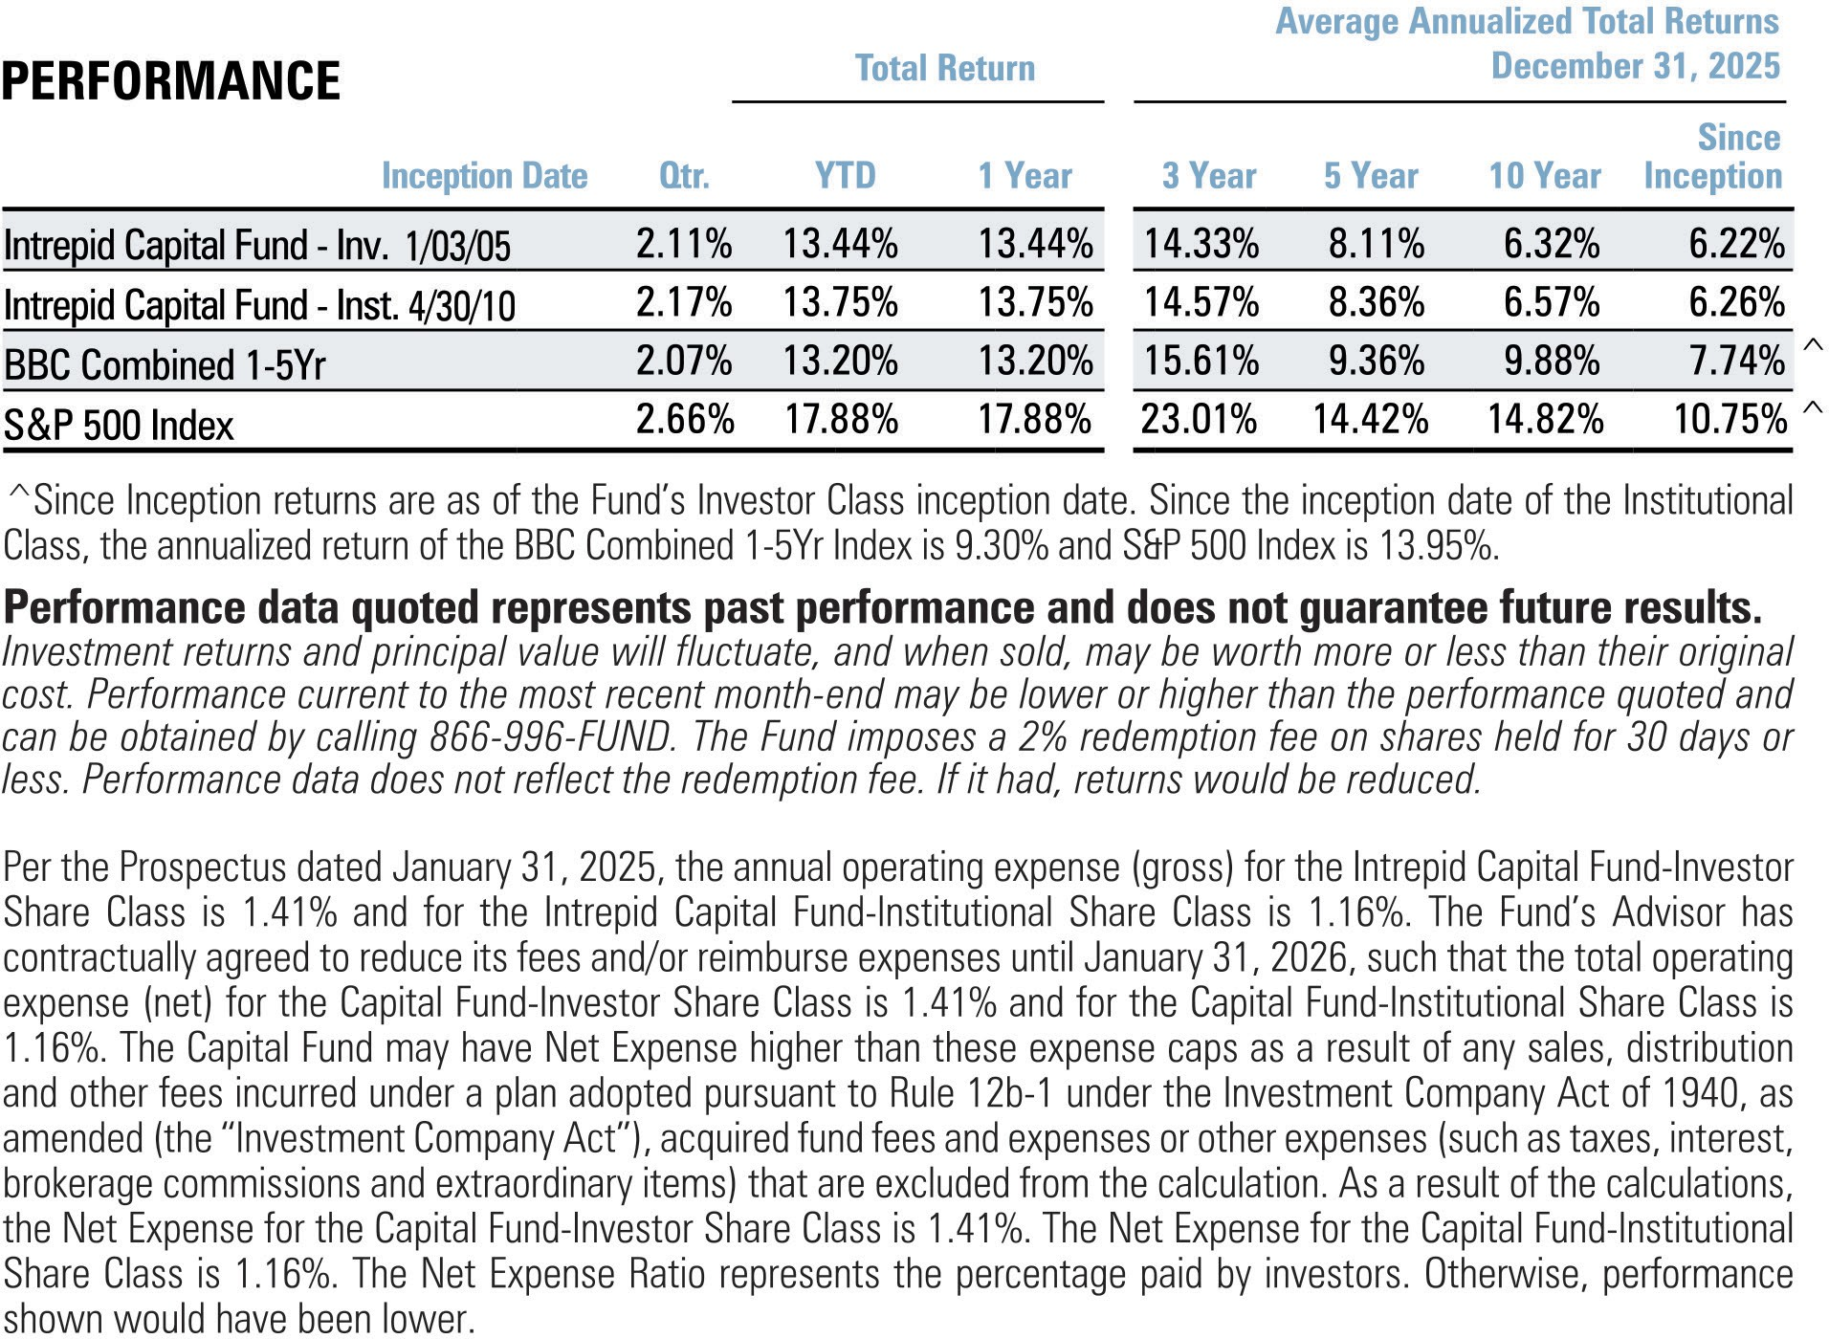

January 4, 2026

“An optimist sees an opportunity in every calamity. A pessimist sees a calamity in every opportunity.”
— Winston Churchill

Dear Fellow Shareholders,
I am pleased to report the Intrepid Capital Fund finished a successful calendar year in 2025 with the Fund’s return of 2.11% in the fourth quarter bringing the annual return to 13.44%. The trailing 3-year and 5-year annualized results were 14.33% and 8.11%, respectively.
The quarterly outcome of slightly over 2% annualizes to roughly 8%, which is what I would come to expect of a fund that holds a mixture of stocks, bonds, and cash over time (as this one does).

We do pay a quarterly dividend, although it was de minimis at the end of December. This significantly lower rate in December compared to September’s .054805 cents per share, June’s .07976 cents per share, and March’s .166937 cents per share is due more to the peculiarities of the bond market, where interest income is paid semi-annually and may not match up perfectly with the December quarter. Dividends of the Fund’s current stock holdings do pay quarterly; they just aren’t particularly high at this point in time. I would anticipate a payout similar to the S&P 500 index, with the potential to end up slightly higher.
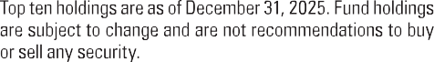
I want to continue to stress the long-term orientation of your portfolio manager and, subsequently, this mutual fund. History does not favor a high-turnover portfolio over lower-turnover portfolios. There are brokerages that have figured out that portfolios that were simply left alone – through death,
divorce, benign neglect, etc. – often outperform the most active ones. As Warren Buffett would suggest, let sloth be your friend as far as your portfolio is concerned. Your doctor will argue the contrary for your physical health, however!
Much like a farmer planting seeds and then waiting for harvest, sometimes many years in the future, I am looking for founder-run businesses as founders care the most about the business’s prospects. In a year-end interview in Barron’s weekly financial magazine, Will Danoff, portfolio manager of the behemoth Fidelity Contrafund, says something similar: “Often large insider ownership suggests management is totally aligned with outside shareholders.” He goes on to say, “Owner-operators tend to be more cautious because their own money and legacy are on the line. Often the founder is thinking differently how to make the right decision for the long term of the company.”
That is the most common theme in the equity portion of the Intrepid Capital Fund as well: founder-led businesses or, at the very least, management with a significant equity ownership. I believe it aligns their interest in business success with ours through common ownership.
To wit, here are names in the portfolio where this is applicable:

- Alphabet
- Berkshire Hathaway
- FRP Holdings
- Liberty Live
- Madison Square Garden Sports
- Sprott
- WR Berkley
- Atlanta Braves Holdings
- Markel Group
- Becle
- IAC
- UniFirst
- Jefferies Financial
- Garmin
- Airbnb
- Green Brick Partners
- Scotts Miracle-Gro
- SS&C Technologies
- Copart
- Levi Strauss
- Dropbox
- Watsco
- Howard Hughes Holdings

In other words, virtually the entire portfolio consists of what Mr. Danoff describes in that interview. This is totally serendipitous, as I have not met, spoken to, or read much about him prior to this interview.

So, as the year progresses, should the wind ever be in our face, the market falling, and your pulse quickening, rest easily knowing these managers have their long-term interests aligned with ours!

For the fourth calendar quarter of 2025, the largest contributors were:
- Alphabet
- Fabrinet
- Dollar Tree
- iShares Gold Trust
- Sprott

For the 4th quarter of 2025, the largest detractors were:
- Watsco
- Green Brick Partners
- Garmin
- Liberty Media Live
- Fiserv

For the full calendar year 2025, the largest contributors were very similar:
- Fabrinet
- Alphabet
- iShares Gold Trust
- Sprott
- Dollar Tree

For the full calendar year 2025, the largest detractors were:
- Civitas Resources
- Jefferies Financial
- Copart
- Fiserv
- FRP Holdings

Thank you for your continued support. If there is anything we can do to serve you better, please don’t hesitate to call.

All the best,
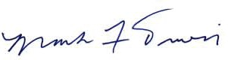

Mark F. Travis,
Intrepid Capital Fund Lead Portfolio Manager

Past performance is not a guarantee of future results.
Mutual fund investing involves risk. Principal loss is possible. The Fund is subject to special risks including volatility due to investments in smaller companies, which involve additional risks such as limited liquidity and greater volatility. Investments in debt securities typically decrease in value when interest rates rise. This risk is usually greater for longer-term debt securities. Investments by the Fund in lower-rated and non-rated securities present a greater risk of loss to principal and interest than higher-rated securities. The Fund may invest in foreign securities which involve greater volatility and political, economic and currency risks and differences in accounting methods. The risks of owning ETFs generally reflect the risks of owning the underlying securities they are designed to track. ETFs also have management fees that increase their costs versus the costs of owning the underlying securities directly.

The Funds’ investment objectives, risks, charges and expenses must be considered carefully before investing. The prospectus contains this and other important information about the investment company. Please read it carefully before investing. A hard copy of the prospectus can be requested by calling 866-996-FUND (3863).
The S&P 500 Index is a broad-based, unmanaged index of 500 stocks, which is widely recognized as representative of the equity market in general. The Bloomberg US Gov/Credit 1-5Y TR Index measures the performance of U.S. dollar-denominated U.S. Treasury bonds, government-related bonds, and investment-grade U.S. corporate bonds that have a remaining maturity of greater than or equal to one year and less than five years. The Bloomberg (BBC) Combined Index consists of an unmanaged portfolio of 60% common stocks represented by the S&P 500 Index and 40% bonds represented by the Bloomberg US Government/Credit 1-5 Yr Index. You cannot invest directly in an index.
The 10-Year US Treasury Note is debt obligation issued by the US government that matures in 10 years.
Opinions expressed are subject to change, are not guaranteed and should not be considered investment advice or recommendations to buy or sell any security.
Dividends are not guaranteed and may fluctuate.
The Intrepid Capital Funds are distributed by Quasar Distributors, LLC.

