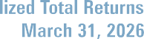

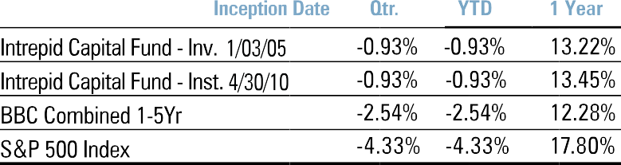
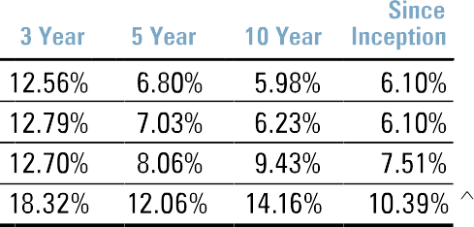
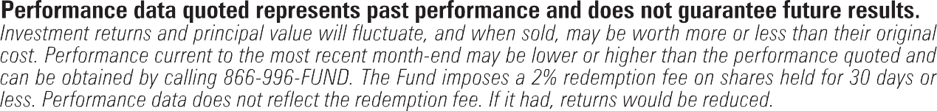
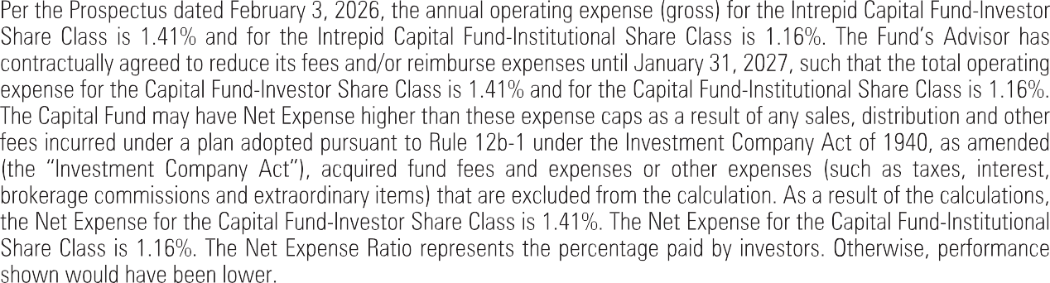

April 10, 2026

“War almost never ends the way starters had in mind.”
— Malcolm Forbes

Dear Fellow Shareholders,
Our Fund’s positive performance was interrupted when bombs started dropping in Iran the last week of February, though we managed to hang on to positive results over the trailing six months. I am pleased to report a positive
+1.16% return over that period, but volatility certainly spiked in March as the market had to digest significantly higher oil prices, along with the guessing game of “would he, or won’t he.” The “he” in this case was Donald Trump and his demands of the theocratic regime in Tehran.
A relentless air war that began with the death of the Supreme Leader and much of his cabinet ended in March with Iran blocking the Strait of Hormuz and choking off 20% of the world’s oil supply, sending the price of oil skyward

and stocks falling. In addition, the “risk free” 10-year US Treasury rate repriced higher roughly 30 basis points to ~4.30%. Gold, often a refuge in falling stock and bond markets, also moved lower in response to all of the above.
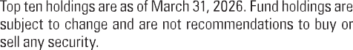
We are now in somewhat of a stalemate in that the regime doesn’t want “change” and the Iranian Revolutionary Guard doesn’t either. Subsequently, they have successfully blocked the Strait and President Trump has called for a two-week truce – brokered by Pakistan. We shall see. Despite all of the excitement listed above the fund ended just modestly down for the first calendar quarter of 2026 (-0.93%) which was relatively favorable to the US equity indices for the same time period. This performance includes a dividend of $0.11932 per share paid on March 31, 2026.

Top contributors for the semi-annual period ending March 31, 2026:

Sprott Inc (SII): | +1.38%
Permian Resources (PR): | +1.04%
Fabrinet (FN): | +1.04%
Madison Square Garden Sports (MSGS): | +0.82%
Alphabet (GOOGL): | +0.80%

Top detractors for the semi-annual period ending March 31, 2026:

Fiserv (FISV): | -1.11%
Jefferies (JEF): | -0.60%
Take Two Interactive Software (TTWO: | -0.57%
Conduent 6% Notes due 11-1-2029 | -0.56%
Copart (CPRT): | -0.39%
Thank you for your continued support. If there is anything we can do to serve you better, please don’t hesitate to call. All the best,
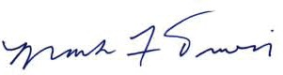
Mark F. Travis,
Intrepid Capital Fund Lead Portfolio Manager

Past performance is not a guarantee of future results.
Mutual fund investing involves risk. Principal loss is possible. The Fund is subject to special risks including volatility due to investments in smaller companies, which involve additional risks such as limited liquidity and greater volatility. Investments in debt securities typically decrease in value when interest rates rise. This risk is usually greater for longer-term debt securities. Investments by the Fund in lower-rated and non-rated securities present a greater risk of loss to principal and interest than higher-rated securities. The Fund may invest in foreign securities which involve greater volatility and political, economic and currency risks and differences in accounting methods. The risks of owning ETFs generally reflect the risks of owning the underlying securities they are designed to track. ETFs also have management fees that increase their costs versus the costs of owning the underlying securities directly.

The Funds’ investment objectives, risks, charges and expenses must be considered carefully before investing. The prospectus contains this and other important information about the investment company. Please read it carefully before investing. A hard copy of the prospectus can be requested by calling 866-996-FUND (3863).
The S&P 500 Index is a broad-based, unmanaged index of 500 stocks, which is widely recognized as representative of the equity market in general. The Bloomberg US Gov/Credit 1-5Y TR Index measures the performance of U.S. dollar-denominated U.S. Treasury bonds, government-related bonds, and investment-grade U.S. corporate bonds that have a remaining maturity of greater than or equal to one year and less than five years. The Bloomberg (BBC) Combined Index consists of an unmanaged portfolio of 60% common stocks represented by the S&P 500 Index and 40% bonds represented by the Bloomberg US Government/Credit 1-5 Yr Index. You cannot invest directly in an index.
The 10-Year US Treasury Note is debt obligation issued by the US government that matures in 10 years.
Opinions expressed are subject to change, are not guaranteed and should not be considered investment advice or recommendations to buy or sell any security.
Dividends are not guaranteed and may fluctuate.
The Intrepid Capital Funds are distributed by Quasar Distributors, LLC.

